Washington State Tsunami Program
FY11 & FY12 Program Achievements
Respectfully Submitted by: John Schelling, Washington Emergency Management Tim Walsh, Washington Department of Natural Resources 1/16/2013

Washington State Tsunami Program
FY11-12 Achievements

The Washington State Tsunami Program is a state-level tsunami risk reduction program that, in cooperation with the National Oceanic and Atmospheric Administration (NOAA) National Weather Service (NWS) and other federal, state and local agencies, and tribes, promotes tsunami planning, preparedness and hazard mitigation among Washington’s coastal communities.
Objective 1. Complete tsunami inundation modeling & dissemination of products to at-risk communities.

- Enhanced Cascadia Subduction Zone modeling for the SW Washington Coast, including Willapa Bay and Grays Harbor, has been completed.

- Inundation modeling for the San Juan Islands is in process by NOAA’s Pacific Marine Environmental Laboratory.

- 39 Community-Based Tsunami Risk Assessment Fact Sheet Project completed by Washington Emergency Management, Washington Department of Natural Resources, & United States Geological Survey for outer coastal communities. Products are available online at: http://www.emd.wa.gov/hazards/haz_tsunami.shtml#TsunamiFactSheets

- Tsunami vertical evacuation planning through Project Safe Haven has been completed in three outer coastal counties & site-specific inundation modeling for construction for two pilot sites will be completed by July 2013.

- The Great Washington ShakeOut Earthquake Drill & Tsunami Evacuation Drill had 714,000+ participants and all coastal schools practiced their evacuation procedures.
  - Tsunami warning sirens were activated with real-world warning tone to initiate the drill.
  - New Zealand’s GNS Science is currently analyzing participation and will provide recommendations on improvements.

- The Washington State-Local Tsunami Workgroup met quarterly and provided coordinated guidance on program objectives and projects as well as participated in the WCATWC PACIFEX tsunami exercise.
Objective 1I. Promote local, regional, and state-level tsunami mitigation & preparedness

- Tsunami vertical evacuation planning through Project Safe Haven has been completed in all outer coastal counties and site-specific inundation modeling for construction for two pilot sites will be completed by July 2013. (www.facebook.com/projectsafehaven)

- The community-based Map Your Neighborhood program continues to be implemented in tsunami at-risk jurisdictions and MYN was the receipient of the Federal Emergency Management Agency (FEMA) National Challenge Award in 2012.

- Emergency supply caches have been established by each of the outer coastal tribes since 2009 & additional life-safety materials are in process for procurement and delivery.
- Washington Emergency Management’s Tsunami Program Assistant continues to work with local jurisdictions on TsunamiReady application as well as conduct outreach to private industry hospitality partners and other key stakeholders.
Objective 1II. Continue development of tsunami notification infrastructure

- Two tsunami warning sirens will be installed in February 2013 in the cities of South Bend and Raymond. With the addition of these sirens, the outdoor tsunami warning system will consist of 57 sirens in tsunami-threatened communities.
  - Washington Emergency Management Telecommunications Section continues to provide maintenance support.
Objective 1V. Work with the TsunamiReady Program to foster communities to become TsunamiReady recognized

- Eight (8) Tsunami Public Education Instructor: Train-the-Trainer Courses are scheduled for delivery during February-July 2013 and nine (9) community-specific instructor manuals have been completed and will be available online.

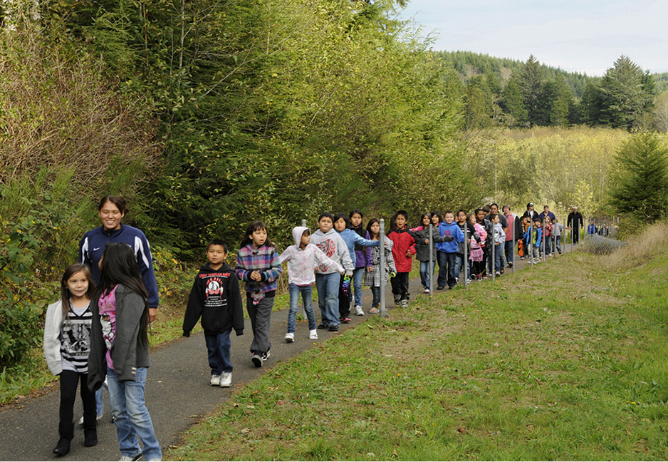
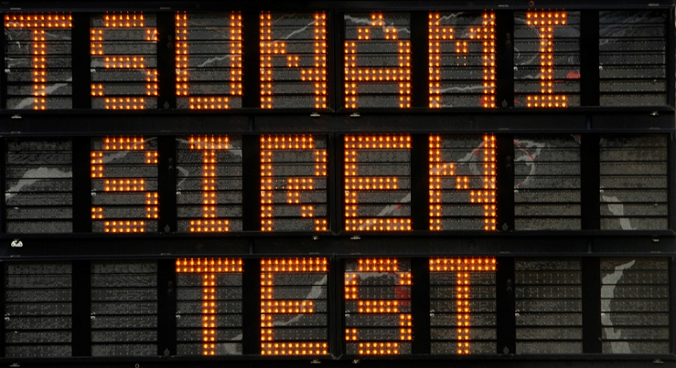
- A variety of tsunami preparedness materials have been printed and distributed including outreach postcards promoting the ShakeOut tsunami evacuation drill, updated tsunami evacuation brochures meeting the new NTHMP Mitigation & Education Subcommittee guidelines, and community-specific newspaper inserts, and a product aimed at integrating tsunami preparedness into K-12 lesson plans entitled “Earthquake and Tsunami: Information and Resources for Schools”. All materials are available online at: http://www.emd.wa.gov/hazards/haz_tsunami.shtml

- 170 new tsunami evacuation signs have been ordered and installed by local jurisdictions throughout Washington State to enhance awareness and demarcate evacuation routes.

- Six (6) deliveries of the Low Income/Special Needs Tsunami Training Program were completed by Washington Emergency Management Division’s Tsunami Program Assistant and 118 NOAA Weather Radios were distributed and programmed by participants.

- The Washington Department of Natural Resources continues to evaluate tsunami evacuation routes and their susceptibility to landslides and liquefaction hazards in order to enhance evacuation & assembly area planning in local communities.
  - Washington Department of Natural Resources continues to make improvements to the Washington Interactive Tsunami Evacuation Mapping portal. This application enables users to identify whether their home, office, school, etc. is located in a tsunami hazard zone. https://fortress.wa.gov/dnr/geology/?Theme=tsunami_evac

- An update and printing of the award-winning “Media Guidebook for Natural Disasters” is in process and will be completed by July 2013.
Objective V. Support the NTHMP through Multi-State Projects

- The Washington Department of Natural Resources continues to print and distribute “TsuInfo Alert”, the quarterly newsletter of the National Tsunami Hazard Mitigation Program and distributes this publication to more than 513 subscribers.

